
Lab Program Number: 28 Date: 14th March,2026
Title: Linux Basic Commands

Some of the basic Linux command are:
- pwd:
The pwd command is used to print the current working directory
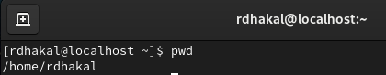
- ls:
The ls command is used to list all files and directories in the current directory.
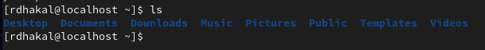
- cd:
The cd command is used to change the current directory to another.
- mkdir:
The mkdir command is used create a new directory or folder.
- touch:
The touch command is used to create a new empty file.
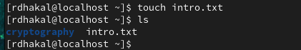
- cp:
The cp command is used to copies a file or directory from one location to another.
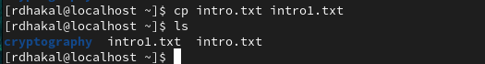

- mv:
The mv command is used to move or rename a file or directory.
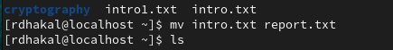
- rm:
The rm command is used to removes file and non-empty directories.
- echo:
The echo command is used to print text to the terminal or writes text into a file
- cat:
The cat command is used to display the contents of a file on the terminal.
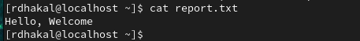
- tree:
The tree command is used to display the directory structure.
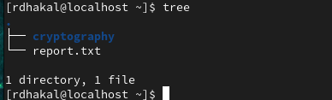
- ls -all:
The ls -all command is used to lists all files and directories including hidden files.
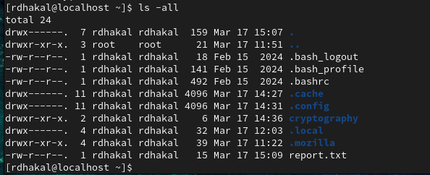

- rmdir:
The rmdir command is used to remove an empty directory from the system.
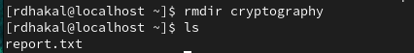
- uptime:
The uptime command is used to show how long the system has been running.
- Head:
The head command is used to display the first few lines of a file, usually the first 10 lines by default.
- Whoami:
The whoami command displays the username of the currently logged-in user in the system.
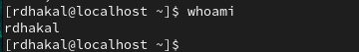
- Chmod:
The chmod command stands for “change mode” and is used to modify the access permissions of a file or directory. Permissions control who can read, write, or execute a file.
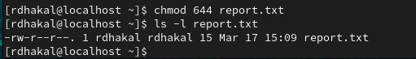
- Chown:
The chown command stands for “change owner.” It is used to change the ownership of a file or directory to a specified user or group.
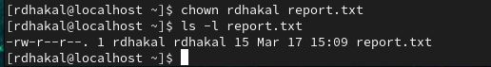

- Man:
The man command displays the manual page for a specific command. It provides detailed information about the command’s usage, options, and examples.
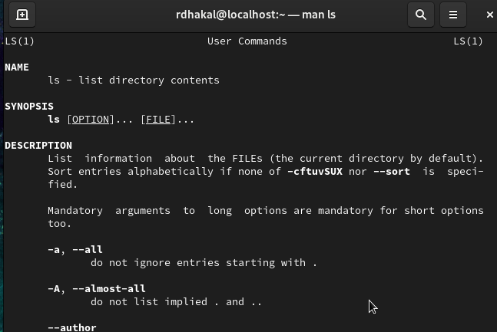
- Clear:
The clear command is used to clear the terminal screen and remove previous commands and outputs from the display.
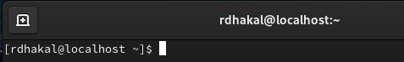

- History:
The history command displays a numbered list of all commands that have been previously executed in the terminal.
